**Lovely Proffessional University**

CSE 326

PROJECTREPORT

ON

**INCOME TAX DEPARTMENT OF INDIA**

SUBMITTED TO: MANU BALI

SUBMITTED BY:

ABHISEKH YADAV (17)

ANJALI NAIN (18)

E.SASI VENKATAVAMSI (16)

**====== OUTLINES=======**

* **ACKNOWLEDGEMENT**
* **INTRODUCTION**
* **PROJECT DESCRIPTION**
* **CONCEPTS USED**
* **DIAGRAM**
* **FLOWCHART**
* **WORK DONE BY TEAM MEMBER**
* **SCREENSHOTS OF WEBSITE**
* **CONCLUSION**
* **REFERENCE**

**ACKNOWLEDGMENTS:**

**In performing our assignment, we had to take the help and guideline of some respected persons, who deserve our greatest gratitude. The completion of this assignment gives us much Pleasure. We would like to show our gratitude Ms. Manu Bali for giving us a good guideline for assignment throughout numerous consultations. We would also like to expand our deepest gratitude to all those who have directly and indirectly guided us in writing this assignment. Many people, especial our team members itself, have made valuable comment suggestions on this proposal which gave us an inspiration to improve our assignment. We thank all the people for their help directly and indirectly to complete our assignment.**

**introduction:**

Top of Form

Bottom of Form

Top of Form

Bottom of Form

This is a small project to design a website on the Income tax department of India.

The basic idea is that customer can aware about the different tax rules and news too. Customer can also pay their taxes. People must have an account to pay taxes and other works like taxpayer services, if they don’t have any account they can only read the news. For that customer can create an account.

Income tax department of India is a system that provides us to tax information and services, taxation rules and also about international tax rules too. This system is very useful to all especially for those who pay taxes.

**PROJECT DESCRIPTION:**

This project is basically based on **HTML**, **CSS** and a bit of **java script** and **j-querry**. In this project there is **six** section

First part contains **website logo** and **heading**.

Second part contains the **navigational bar.**

Third part contains **news** section using **marquee tag** .

Fourth part is divided into three parts:

1. For making **login and sign** up forms.
2. For displaying **what’s new** for today.
3. For is divided between two parts (i) For displaying links for **important links** and(ii) For displaying **FAQs.**

Fifth part contain link about different services for tax paying and rules and regulation.

Sixth part of this project contains the desclaimer.

**CONCEPT USED:**

TAG NAME AND DESCRIPTION:

HEADER:

The header of the website is the consistent area at the top of site that include the logo and navigation menu

A header might include:

* Logo
* Navigation menu
* Tagline
* Phone number
* Address
* Search box
* Login or my account link

**<!DOCTYPE>:**

This is the document type tag, which is actually not a tag, but a declaration of the version of HTML that is used. It is to help the browser understand the version and type of web page, without which the browser would not be able to even recognize the webpage. The document type tag does not have an end tag.

**<a>:**

The anchor tag, as this tag is called, interconnects two pages (unidirectional) with the help of a page address. The link of the interconnected page needs to be inserted as part of the href attribute, which makes the text accessible, and directs you to the said page on clicking the linked text.

**<b>:**

The bold tag is used, as the name suggests, to make text bold, or stand out from other text on a webpage. Similar to the bold effect found in most word processing programs.

**<body>:**

The body tag displays all the content of an HTML document, such as text, hyperlinks, images, tables, lists, etc.

**<br>:**

This tag lets you add a line break to the text. It puts anything that comes after it on a new line. The line break tag is an empty tag, meaning it has no end tag.

**<button>:**

The button tag defines a clickable button. Inside this tag you can put content, like text or images.

**<center>:**

The center tag is used to align elements or text to the center of the page. This tag is not supported in HTML 5, CSS properties need to be used instead.

**<form>:**

The form tag is one of the most important aspects of interactive pages. It is used to create an HTML form for user input.

**<font>:**

This tag is similar to the basefont tag, except it applies the font style to the content and elements within the tag, and not across the whole page. The font tag is not supported in HTML 5, CSS is used instead.

**<head>:**

As the name states, the head tag is mainly responsible for the functioning of the body. The head tag includes all the script and style elements, and must include a title for the document

**<header>:**

The header tag specifies a header for a document or section. The header element should be used as a container for introductory content or a set of navigational links.

**<h1> to <h6> :**

The h1 to h6 tags are used to define HTML headings. They add highlight and font style to let the heading of the section stand out. h1 defines the most important heading, while h6 defines the least important.

**<input>:**

As the name suggests, an author can accept inputs from users making a page interactive, using this tag. It is used within the form tag.

**<p>:**

The p tag defines a paragraph on the page.

**<script>:**

The script tag enables the author to insert scripting language into document, such as JavaScript. This tag lets you validate, manipulate, and affect content dynamically.

**FLOW CHART:**

* ICON: we have used **<img src>** tag to add icon.
* HEADING: we used **inline css** and **<h1>** tag for designing heading.
* NAVIGATIONAL BAR: we made the navigational bar horizontal, used **<nav>** tag, **internal css**, used **<button>** tag to design it to acts as button, used **hover effect**.
* NEWS SECTION: we used ***<marquee>*** tag to display news and welcome message too, used **internal css**, and given direction to rotate up to down.
* 3 VERTICLE LAYOUTS: we have used to **<div>** tag to design three layouts and set their dimensions using **inline css**.
* FIRST VERTICLE LAYOUT: designed login and sign up forms by using **<form> tag**, used inline css to design it, used **toggle function**(j querry) to flip the forms, used **<button>** tags for submit and login buttons, used **<p>** tag for displaying that password meet those conditions, used **<a=href” ”>** tags to give links.
* SECOND VERTICLE LAYOUT: designed for news, used **<a href=” ”>** tag to give links to news, used *unordered lists* **<ul>** tag , inline css, **<h2>** tag for heading.
* THIRD VERTICLE SECTION: used to display important links and faqs by using **<a href=” ”>** links , used **inline css** and **<h2>** tags.
* ALL RELATED TO TAX SYSTEM: we have used to **<div>** tag to design three layouts and set their dimensions using **inline css**.
* FIRST TAX-VERTICLE LAYOUT: designed for tax information and related service using *unordered lists* **<ul>** tag, used **<a=href” ”>** tags to give links.
* SECOND TAX-VERTICLE LAYOUT: designed for tax laws and rules, used **<a href=” ”>** tag to give links, used *unordered lists* **<ul>** tag , inline css, **<h2>** tag for heading.
* THIRD TAX-VERTICLE SECTION: used to display international taxation rules by using **<a href=” ”>** links , used **inline css** and **<h2>** tags for heading, used *unordered lists* **<ul>** tag.
* DESCLAIMER : designed for desclaimer, used **<a href=” ”>** tag to give links, used *unordered lists* **<ul>** tag , inline css, **<h2>** tag for heading.
* Used java script to give alerts and also used in login sin forms.

**WEBSITE SCREENSHOTS**

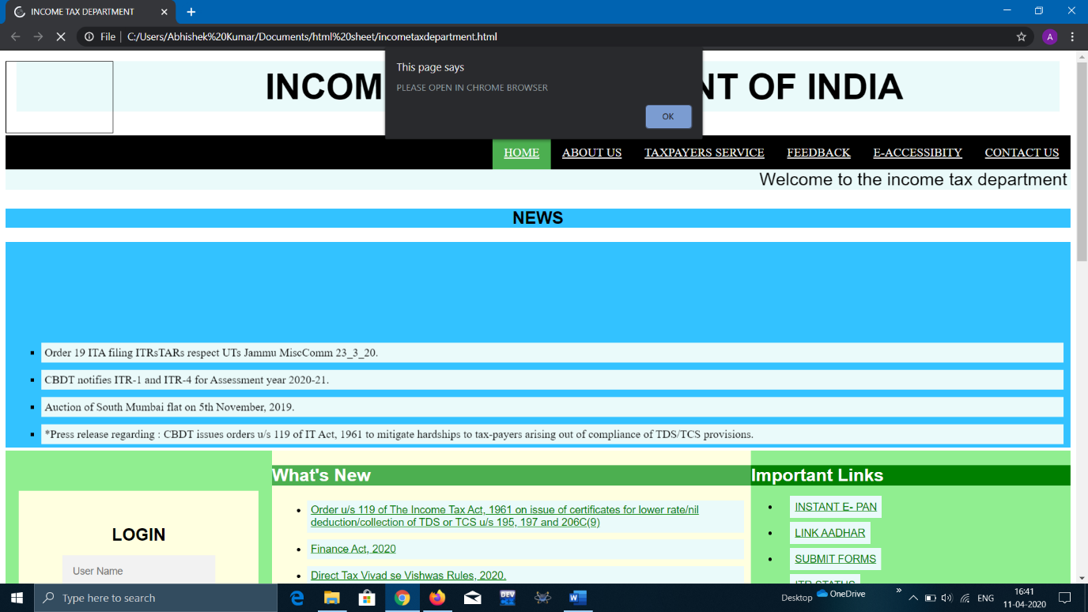

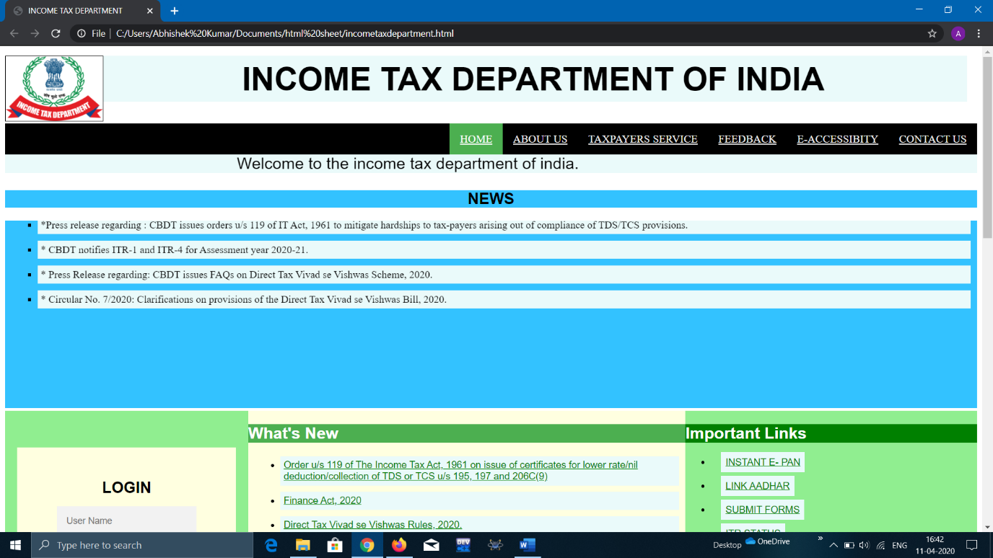

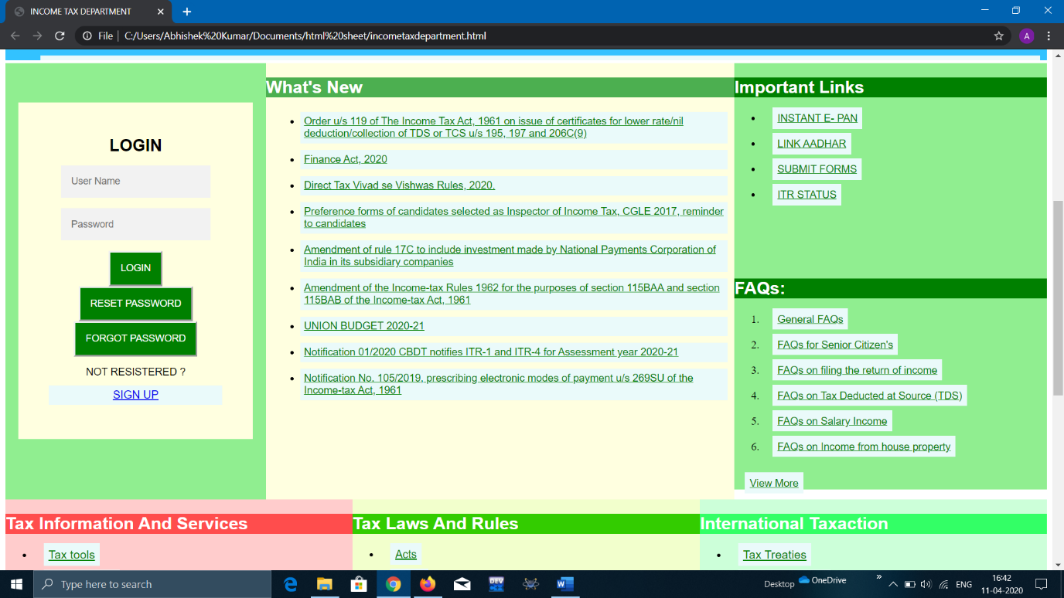

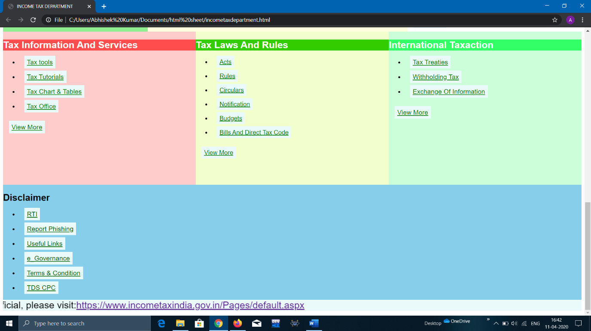

**TEAM WORK**:

BY

**Abhishek yadav:**

I design the all the fronted page like adding logo add all the button and use java script to call the function to perform any action like for login page signup page. I also designed navigational bar and displayed news using marquee tag.

**E-sasi venkatavamsi**:

I change the color and give the location of content using css. I used list tags to make a news section and important links and faqs.

**Anjali nain:**

Firstly I learnt all the required concept to develops a website. I have designed the footer part ie the tax system part and desclaimer part.